- What is St. Paul commandment to the children?
____________________________________________________________________________

____________________________________________________________________________

- Which one of the Ten Commandments came with a promise? (Eph 6:2,3)
a) You shall not bear false witness against your neighbor.
b) Remember the Sabbath day, to keep it holy.
c) You shall have no other gods before Me.
d) Honor your father and your mother.
And what is the promise? _____________________________________________________

- “And you, _______________, do not ______________ your _____________ to wrath, but _______________ them up in the _____________ and ___________________ of the Lord.”

- True or False:
For whatever good anybody does, he will receive the same from God regardless if he is slave or free.

- Whom do we wrestle against? (Eph 6:12)

____________________________________________________________________________

____________________________________________________________________________

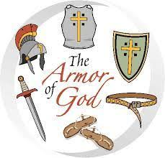

- St. Paul want us to take up the whole armor of God:
The Belt of ______________________. (Eph 6:14)
The Breastplate of ______________________. (Eph 6:14)
Feet prepared with ______________________. (Eph 6:15)
The shield of ______________________. (Eph 6:16)
The helmet of ______________________. (Eph 6:17)
The sword of ______________________. (Eph 6:17)

- True or False: (Eph 6:20)
St. Paul described himself as the “honored ambassador” of Christ.

